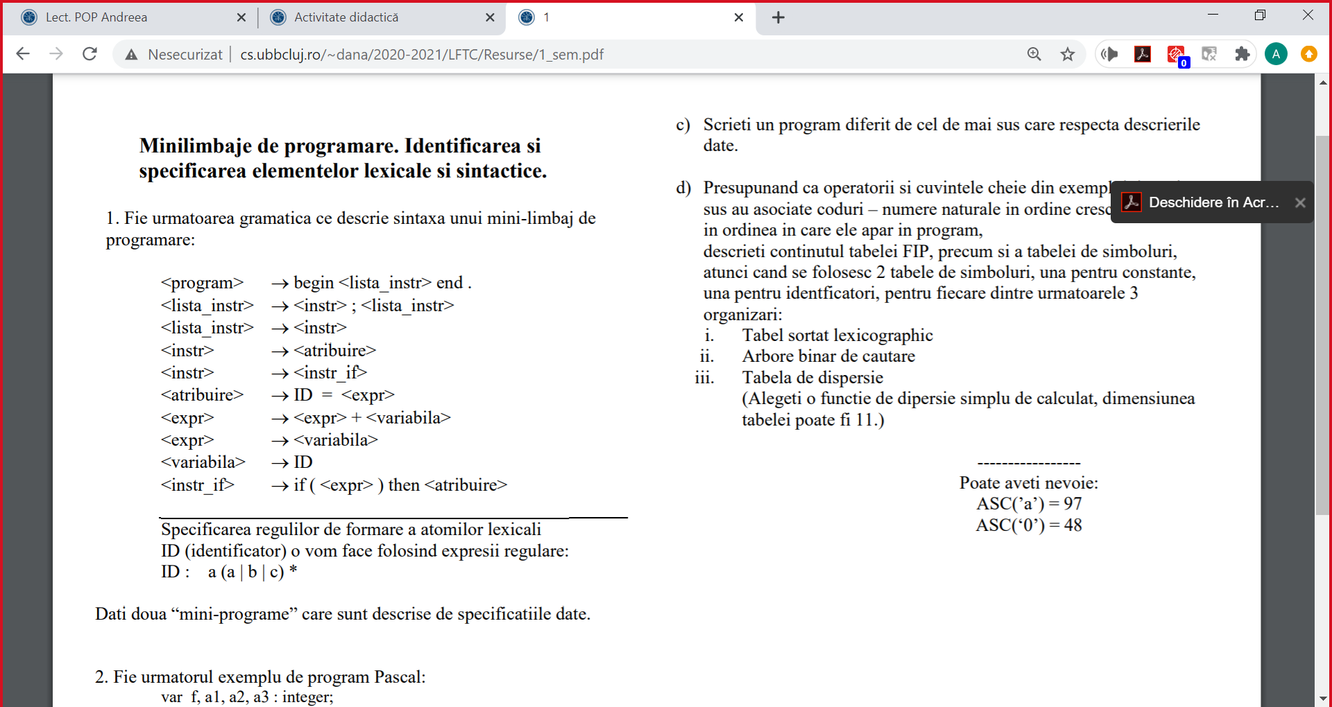

begin a=ab; if(a) then ac=a end.

begin  
    aa = a;  
    ab = a;  
    ac = aa + ab;  
    if (ac + a) then ac = a  
end.

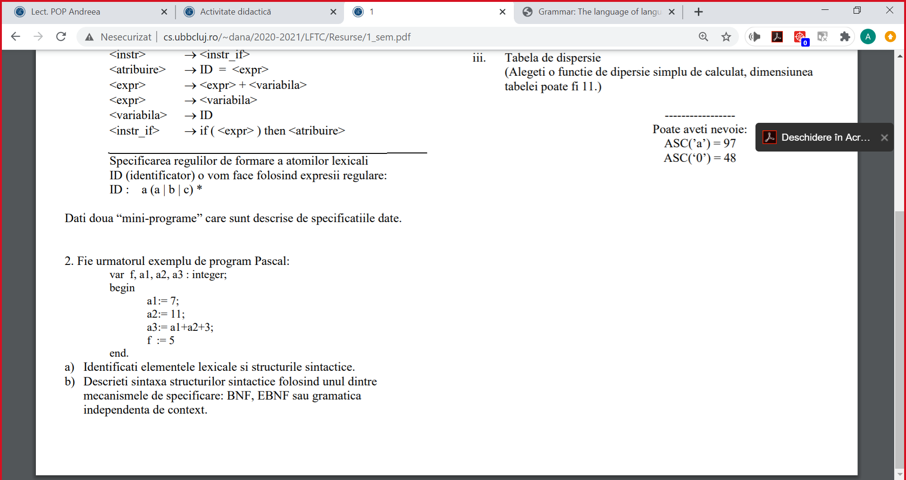

**Elemente lexicale:**

Cuvinte rezervate: var, begin, end, integer

ID: f, a1, a2, a3

CONST: 7, 11, 3, 5

Separatori & Delimitatori: “,”, “;”, “.”, “ “, “\n”, “ tab”

Operatori: “:=”, “:”, “+”

**Structurile sintactice:**

Declarație, Bloc program, Listă instr., Instr., Atrib., Expr.



**GIC:**

<program> ® <decl> begin <instr_list> end .  
<decl> ® var <variable_list> : <variable_type>;

<instr_list> ® <instr> ; <instr_list>  
<instr_list> ® <instr>  
<instr> ® <instr_assignment>  
<instr_assignment> ® ID := <expr>

<expr> ® <expr> + ID  
<expr> ® ID  
<expr> ® CONST

<variable_list> ®ID, <variable_list>  
<variable_list> ® ID  
<variable_type> ® integer

Elemente lexicale:

IDÎ ([a-z][1-9])*

CONST Î ([1-9])([0-9])*

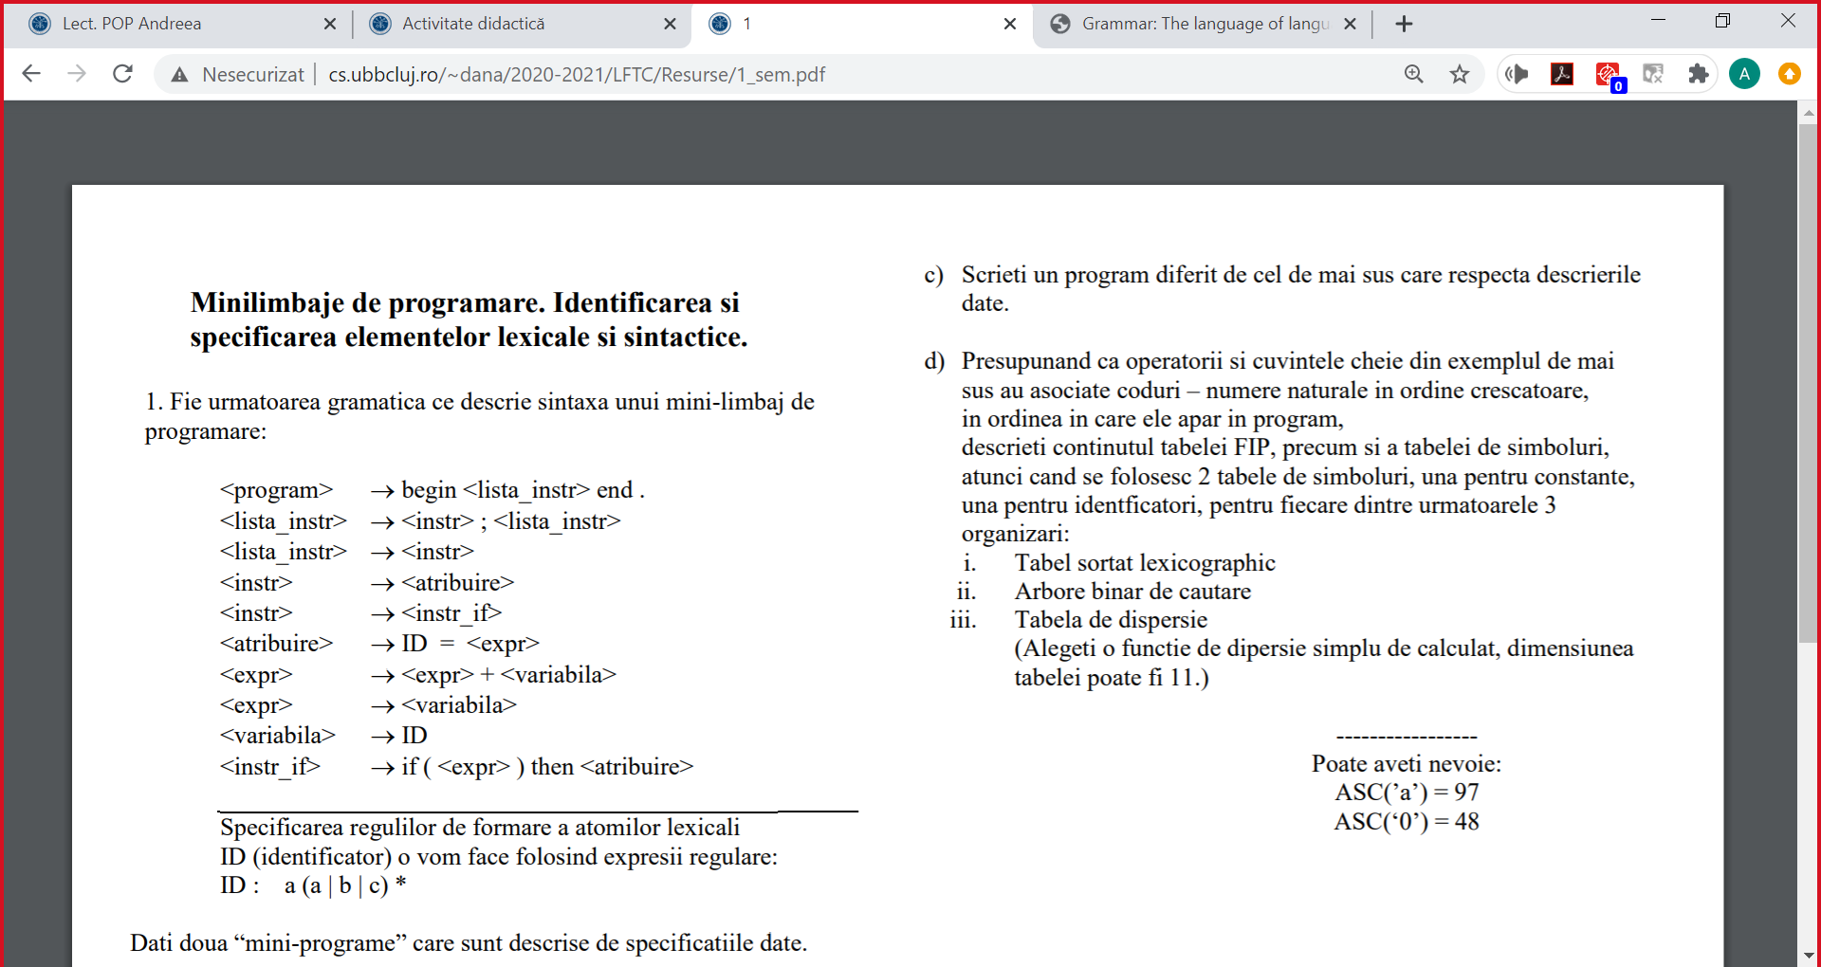

|  |  |
| --- | --- |
| <program> ® <decl> begin <instr_list> end . <decl> ® var <variable_list> : <variable_type>;    <instr_list> ® <instr> ; <instr_list> <instr_list> ® <instr> <instr> ® <instr_assignment> <instr_assignment> ® ID := <expr>    <expr> ® <expr> + ID <expr> ® ID <expr> ® CONST    <variable_list> ®ID, <variable_list> <variable_list> ® ID <variable_type> ® integer | var f, a3, a2, a1 : integer; begin a1:= 1; a2:= 2; a3:= a1+a2; f := 3 end. |



|  |  |  |  |  |  |  |  |
| --- | --- | --- | --- | --- | --- | --- | --- |
| tabelă ordonată lexicofgrafic (alphabetic) | | | | | | | |
| **Atom lexical** | **Cod Atom** | **Programul (fis. De intrare)** | FIP  Forma Internă a Programului | | TS  Tabela de Simboluri (ID) | | |
| ***Cod Atom*** | ***COD TS*** | Simbol (ID) | Cod TS | |
| a1  a2  a3  f | 2  3  4  1 | |
| ID  CONST  begin  var  :  end  .  ;  +  :=  integer  , | 1  2  3  4  5  6  7  8  9  10  11  12 | var  f  ,  a1  ,  a2  ,  a3  :  integer  ;  begin  a1  :=  7  ;  a2  :=  11  ;  a3  :=  a1  +  a2  +  3  ;  f  :=  5  end  . | 4  1  12  1  12  1  12  1  5  11  8  3  1  10  2  8  1  10  2  8  1  10  1  9  1  9  2  8  1  10  2  6  7 | -  1  -  2  -  3  -  4  -  -  -  -  2  -  1  -  3  -  2  -  4  -  2  -  3  -  3  -  1  -  4  -  - | TS  Tabela de Simboluri (CONST) | | |
| Simbol (CONST) | | Cod TS |
| 11  3  5  7 | | 2  3  4  1 |

|  |  |  |  |  |  |  |  |
| --- | --- | --- | --- | --- | --- | --- | --- |
| Arbore binar de căutare | | | | | | | |
| **Atom lexical** | **Cod Atom** | **Programul (fis. De intrare)** | FIP  Forma Internă a Programului | | TS  Tabela de Simboluri (ID) | | |
| ***Cod Atom*** | ***COD TS*** | Simbol (ID) | Cod TS | |
|  | | |
| ID  CONST  begin  var  :  end  .  ;  +  :=  integer  , | 1  2  3  4  5  6  7  8  9  10  11  12 | var  f  ,  a1  ,  a2  ,  a3  :  integer  ;  begin  a1  :=  7  ;  a2  :=  11  ;  a3  :=  a1  +  a2  +  3  ;  f  :=  5  end  . | 4  1  12  1  12  1  12  1  5  11  8  3  1  10  2  8  1  10  2  8  1  10  1  9  1  9  2  8  1  10  2  6  7 | -  1  -  2  -  3  -  4  -  -  -  -  2  -  1  -  3  -  2  -  4  -  2  -  3  -  3  -  1  -  4  -  - | TS  Tabela de Simboluri (CONST) | | |
| Simbol (CONST) | | Cod TS |
|  | | |

|  |  |  |  |  |  |  |  |
| --- | --- | --- | --- | --- | --- | --- | --- |
| tabelă de dispersie cu dim. 11  funcția de dispersie = (suma codurilor ascii) mod 11 | | | | | | | |
| **Atom lexical** | **Cod Atom** | **Programul (fis. De intrare)** | FIP  Forma Internă a Programului | | TS  Tabela de Simboluri (ID) | | |
| ***Cod Atom*** | ***COD TS*** | Simbol (ID) | Cod TS = poz. Din tabelă | |
| f  a1  a2  a3 | 0  1  2  3  4  5  6  7  8  9  10 | |
| ID  CONST  begin  var  :  end  .  ;  +  :=  integer  , | 1  2  3  4  5  6  7  8  9  10  11  12 | var  f  ,  a1  ,  a2  ,  a3  :  integer  ;  begin  a1  :=  7  ;  a2  :=  11  ;  a3  :=  a1  +  a2  +  3  ;  f  :=  5  end  . | 4  1  12  1  12  1  12  1  5  11  8  3  1  10  2  8  1  10  2  8  1  10  1  9  1  9  2  8  1  10  2  6  7 | -  -  -  -  -  -  -  -  -  -  -  -  -  -  -  -  -  -  - | TS  Tabela de Simboluri (CONST) | | |
| Simbol (CONST) | | Cod TS= poz. Din tabelă |
| 7  3  5  11 | | 0  1  2  3  4  5  6  7  8  9  10 |